**Sharing here links regarding tricks of DS and AOA imp topics.**

**Note:-** For every topic:- You must know about its working procedural, Rules, Applications, any imp formulas, Worst/bets case Time and space complexity,and tricks to solve problems on them. (for ex. add,delete,insert elements).

**Imp. Links**

|  |  |
| --- | --- |
| **Stack prefix,postfix,infix conversion** | **<https://runestone.academy/runestone/books/published/pythonds/BasicDS/InfixPrefixandPostfixExpressions.html>**  **https://www.youtube.com/watch?v=vq-nUF0G4fI**  **https://www.youtube.com/watch?v=jos1Flt21is** |
| **Binary preorder,post order and inorder tree traversal** | **<https://www.youtube.com/watch?v=WLvU5EQVZqY>**  **https://www.youtube.com/watch?v=p3YUlEZr2vM** |
| **Max heap and min heap prg solving**  **1.Build min/max heap**  **2. Insert/delete/add/ an element in heap**  **3. Heap properties and best worst case complexity** | **<https://www.geeksforgeeks.org/binary-heap/>**  **<https://www.geeksforgeeks.org/binary-heap/>**  **<https://www.youtube.com/watch?v=a9E-rTIm3Yg>**  **https://www.youtube.com/watch?v=njmr_D3E-dM** |
| **Spanning tree** | **https://www.youtube.com/watch?v=_RqqzyWDVMA**  **https://www.youtube.com/watch?v=vNhvBrc02G4** |
| **BFS** | **<https://www.youtube.com/watch?v=QRq6p9s8NVg>** |
| **DFS** | **https://www.youtube.com/watch?v=iaBEKo5sM7w** |
| **Disktras** | **<https://www.youtube.com/watch?v=WN3Rb9wVYDY>**  **https://www.youtube.com/watch?v=_lHSawdgXpI** |
| **Stack** | **<https://www.youtube.com/watch?v=7SbZKSD3hN4>**  **https://www.youtube.com/watch?v=1SWr7q121gc** |
| **Queue** | **https://www.youtube.com/watch?v=XuCbpw6Bj1U** |
| **Adjacency matrix** | **https://www.youtube.com/watch?v=9C2cpQZVRBA** |

**CapGeminai Drive Details**

**Last year CG executed theses rounds. For Ay 2021-22 CG round details has not yet disclosed.**

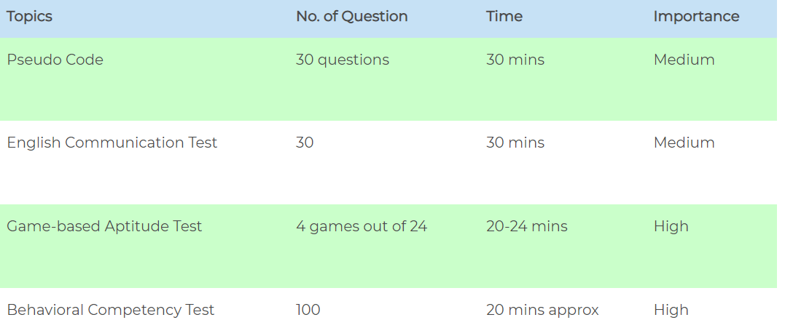

Coding (if you take up the 6.5 LPA package role)